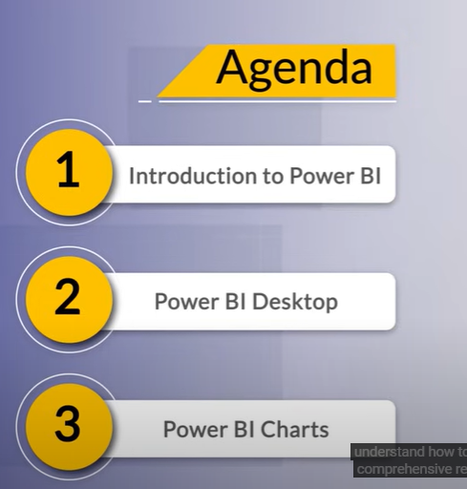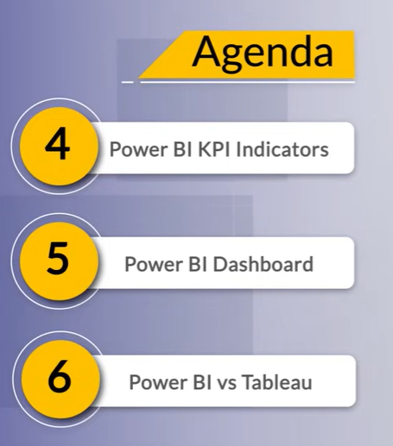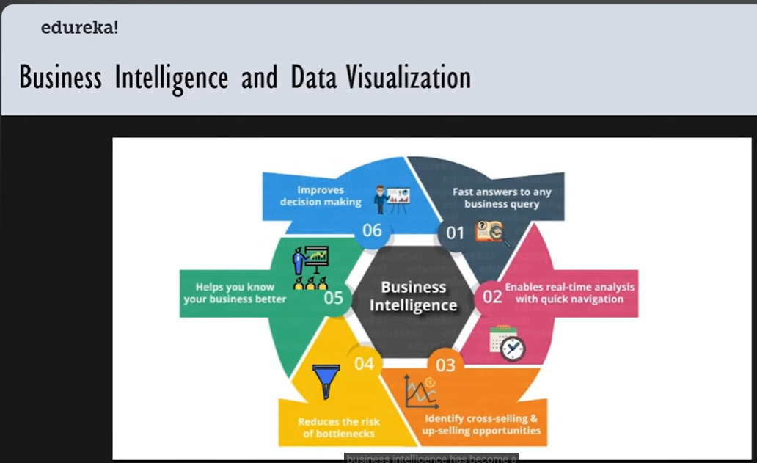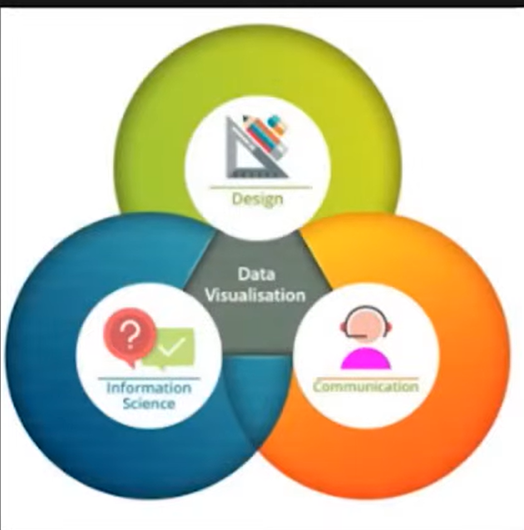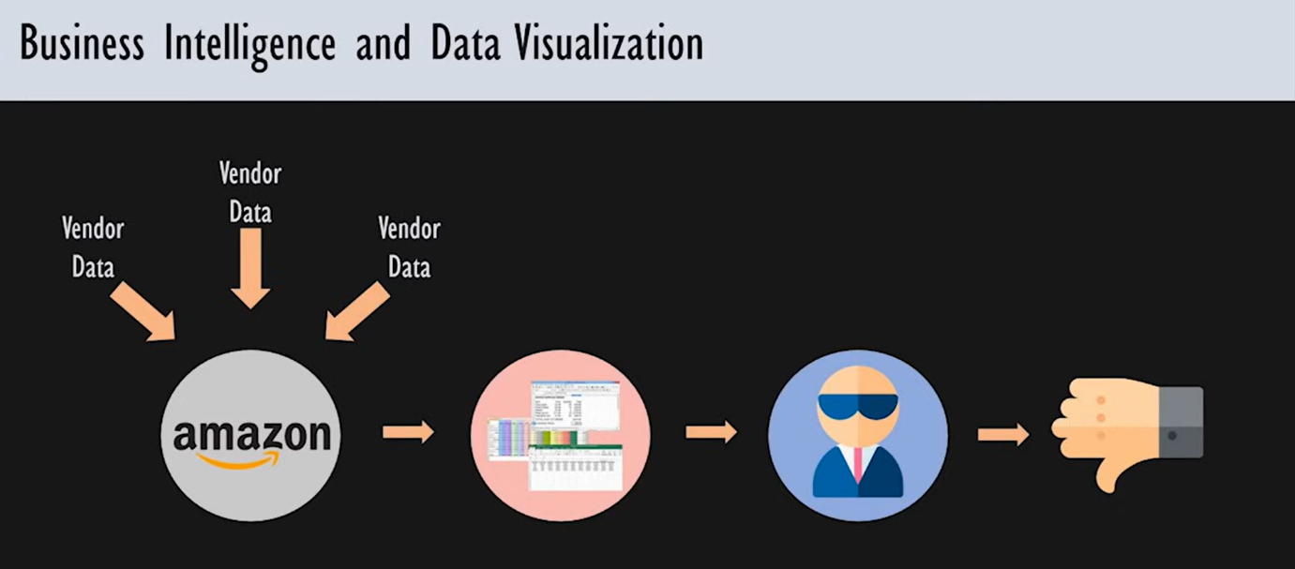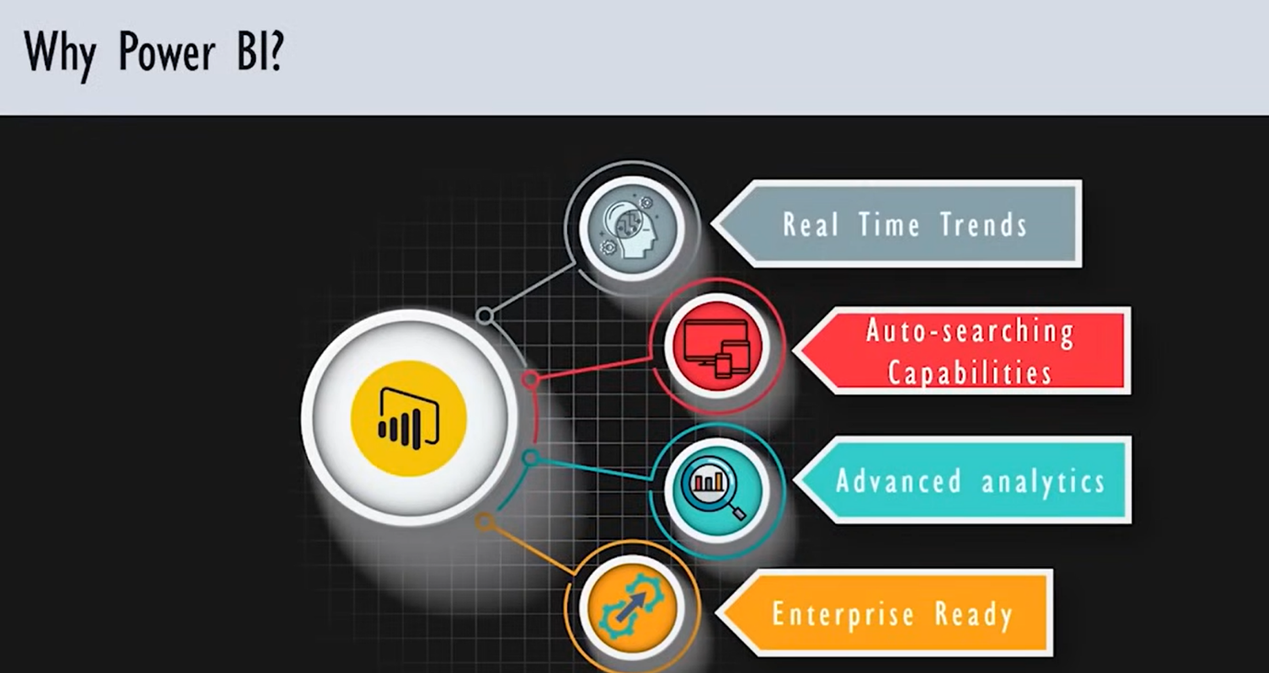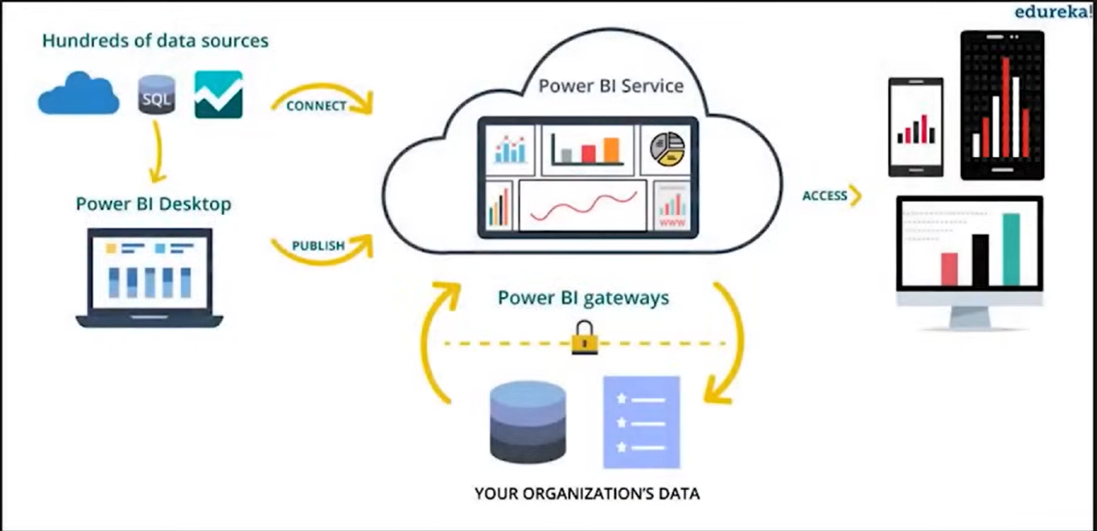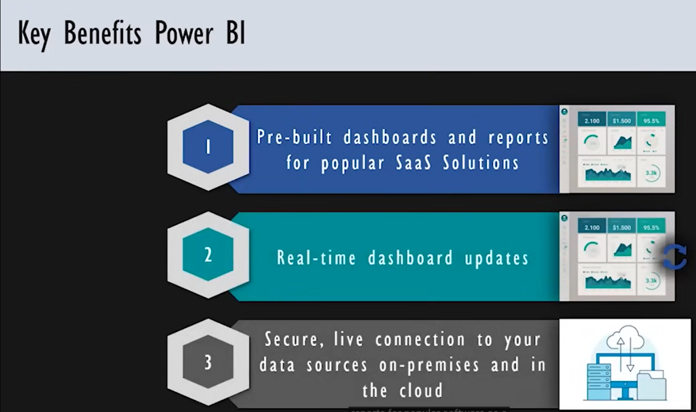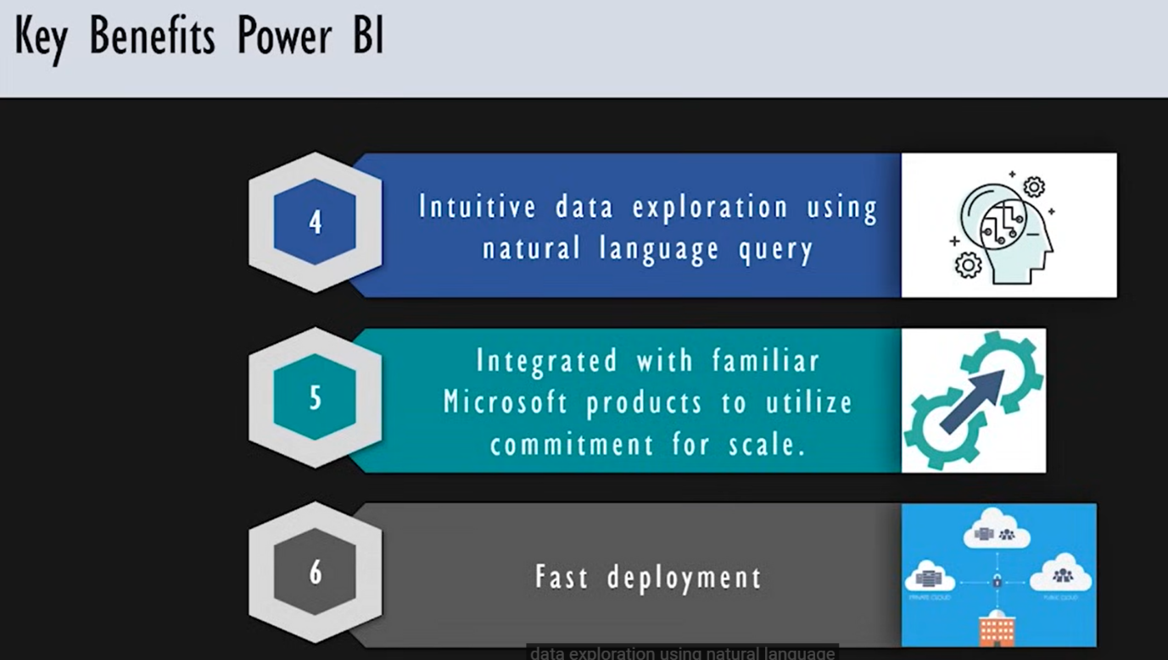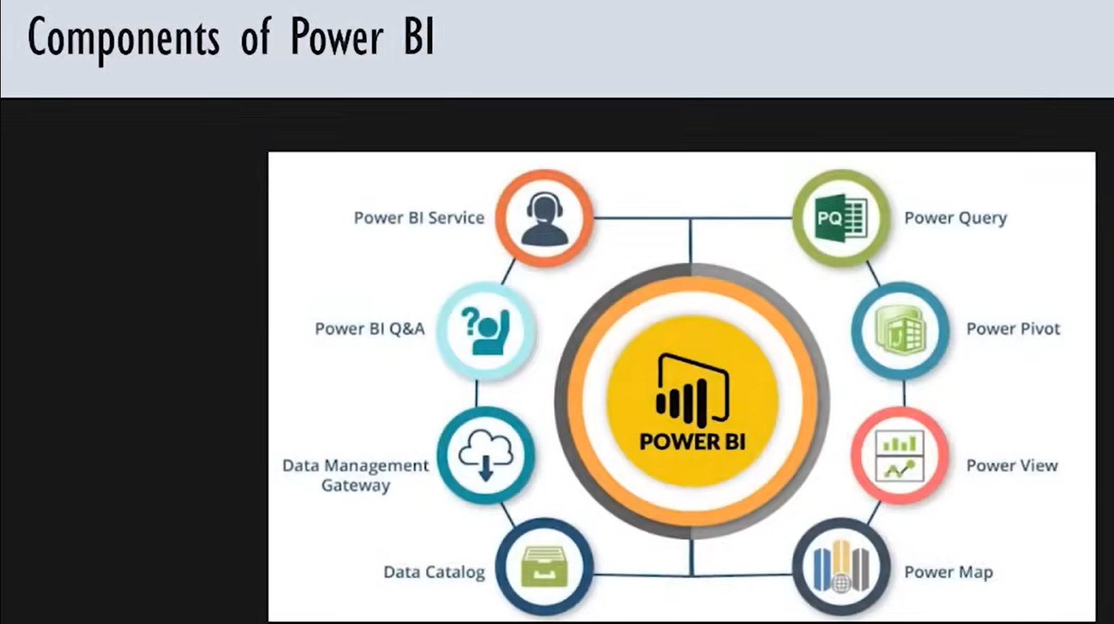

Power BI, a business analytics service by Microsoft, provides interactive visualizations and business intelligence capabilities with an interface simple enough for users to create their own reports and dashboards. It has several key components, each designed to help with different aspects of data analysis and visualization.

**1. Power BI Desktop**

Power BI Desktop is the primary tool for data analysis and report creation. Users can connect to multiple data sources, transform the data, and create visualizations. It's typically used by data analysts and other professionals who need to generate in-depth reports and analyses.

**2. Power BI Service**

This is the cloud-based component where users can publish, share, and access reports and dashboards. It allows for collaboration and access to reports from any location with an internet connection. The service supports real-time data monitoring and automated updates.

**3. Power BI Mobile**

Power BI Mobile applications are available for iOS, Android, and Windows devices, providing access to dashboards and reports on the go. It enables users to stay connected to their data and perform monitoring from anywhere.

**4. Power BI Report Server**

This is an on-premises server where users can publish Power BI reports after creating them in Power BI Desktop. It's suitable for organizations that need to keep their data and reports on local servers due to regulatory or privacy concerns.

**5. Power BI Embedded**

This allows developers to embed Power BI reports and dashboards into their own applications, providing advanced analytics and visualization capabilities. It's used to add a layer of interactivity and analysis within custom applications.

**6. Power Query**

Power Query is a data connection and transformation tool found within Power BI. It enables users to connect to multiple data sources, shape and transform the data, and prepare it for analysis.

**7. Power Pivot**

Power Pivot provides data modeling capabilities for creating complex data models, building relationships between tables, and performing advanced calculations using DAX (Data Analysis Expressions).

**8. Power View**

Power View is a tool that allows for interactive data exploration and visualization. Users can create intuitive and interactive dashboards and reports that can be easily shared and consumed.

**9. Power Map**

Power Map, now part of the standard Power BI toolbox, is a 3D visualization tool that helps in mapping geographic and temporal data, creating engaging and informative displays.

**10. Power BI Gateway**

This component connects Power BI to on-premises data sources, allowing for secure data transfer and refresh between local databases, files, and the Power BI service.

**11. Power BI Visuals Marketplace**

This is an online repository where users can find and download custom visuals created by Microsoft and the community to enhance their reports and dashboards.

**12. Power BI Dataflows**

Dataflows allow for the creation and management of reusable data transformation logic that can be used across different Power BI reports and datasets. They help maintain data consistency and simplify complex ETL processes.

Each of these components plays a crucial role in the Power BI ecosystem, catering to different user needs and organizational requirements for data analysis and visualization. If you have specific questions about any of these components or need help with certain features, feel free to ask!